CS 340 README Final Project

About the Project/Project Title

Austin Animal Center CRUD Python Module and Dashboard:
This project is a full-stack application that connects a MongoDB database containing Austin Animal Center data into an interactive dashboard. The project uses an object-oriented AnimalShelter class that provides database functionality with Create, Read, Update, and Delete operations. The CRUD Python module allows the dashboard to retrieve and filter animal records directly from MongoDB. The dashboard was created using Dash and includes an interactive data table, rescue type filtering options, a breed distribution pie chart, and an interactive geolocation map. These features allow users to identify dogs that meet the preferred requirements for water rescue, mountain/wilderness rescue, and disaster/individual tracking.

Motivation

The purpose of this project is to separate database operations from the user interface while creating a reusable and maintainable application. The MongoDB CRUD functionality is contained within the AnimalShelter Python class which allows other Python programs to access the database without rewriting the database connection and query code. This reusable design was then connected to an interactive Dash dashboard that allows Grazioso Salvare to search and visualize animal records. The dashboard makes it easier for users to identify dogs that meet specific rescue-training requirements by using filtering options, an interactive data table, a breed distribution pie chart, and an interactive geolocation map.

Getting Started

The Austin Animal Center dataset was imported into MongoDB using the database name aac and the collection name animals. A MongoDB account named aacuser was created in the admin authentication database and given the readWrite role for the aac database.

The CRUD_Python_Module.py file contains the AnimalShelter class which creates a MongoDB connection when instantiated. The create() method validates that the input is a nonempty Python dictionary, inserts the document with insert_one(), and returns true if MongoDB acknowledges the insert. The read() method accepts a dictionary containing query criteria, uses MongoDB’s find() method, and converts the resulting cursor into a Python list. The update() method accepts a query and a dictionary of updated values, uses update_many() with the $set operator, and returns the number of documents that are modified. The delete() method accepts a query, uses delete_many() to remove any matching documents, and returns the number of documents that are deleted.

For Project Two, the CRUD module is imported into ProjectTwoDashboard.ipynb and used to retrieve data from MongoDB for the dashboard. The dashboard begins with an unfiltered view of the animal records and uses MongoDB queries to filter dogs based on the rescue requirements provided by Grazioso Salvare. The filtered data is then displayed in the interactive data table, breed distribution pie chart, and the geolocation map.

Installation

This project uses the following tools:

Python 3 is used to create the object-oriented CRUD module, process data, and build the dashboard application.

MongoDB is used as the document database that stores the Austin Animal Center records. MongoDB allows the documents to be stored as flexible document-based data.

PyMongo is the Python driver used to connect the Python module to MongoDB. It provides the MongoClient, insert_one(), find(), update_many(), and delete_many() functionality used by the CRUD module.

Dash is used to create the interactive web dashboard. Dash provides the components and callback structure needed to connect the user interface to the filtered data.

Plotly Express is used to create the breed distribution pie chart that updates based on the currently filtered list of animals.

Dash Leaflet is used to create the interactive geolocation map and display the location of selected animals.

Pandas is used to convert MongoDB query results into DataFrames so the data can be used by the Dash data table, chart, and map.

JupyterLab and Jupyter Notebook is used to execute and test the Python module interactively. This makes it easy to view the results of the Create, Read, Update, and Delete operations.

Codio provides the course development environment that contains MongoDB, JupyterLab, and the AAC dataset.

Usage

Code Example
The CRUD_Python_Module.py file is imported into the dashboard so the AnimalShelter class can be used to connect to MongoDB. The dashboard creates an instance of the class using the database username and password and then uses the read() method to retrieve records from the animals collection. The returned data is then converted into a Pandas DataFrame and displayed into the interactive dashboard.
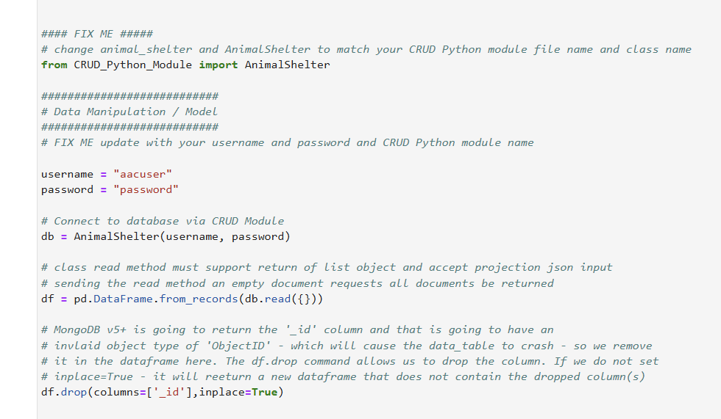

Tests

The CRUD module was tested using the ProjectOneTestScript.ipynb. The test notebook imported the AnimalShelter class, created an object, inserted a new test record, queried MongoDB for the newly created record, updated the created record, and deleted the same record.
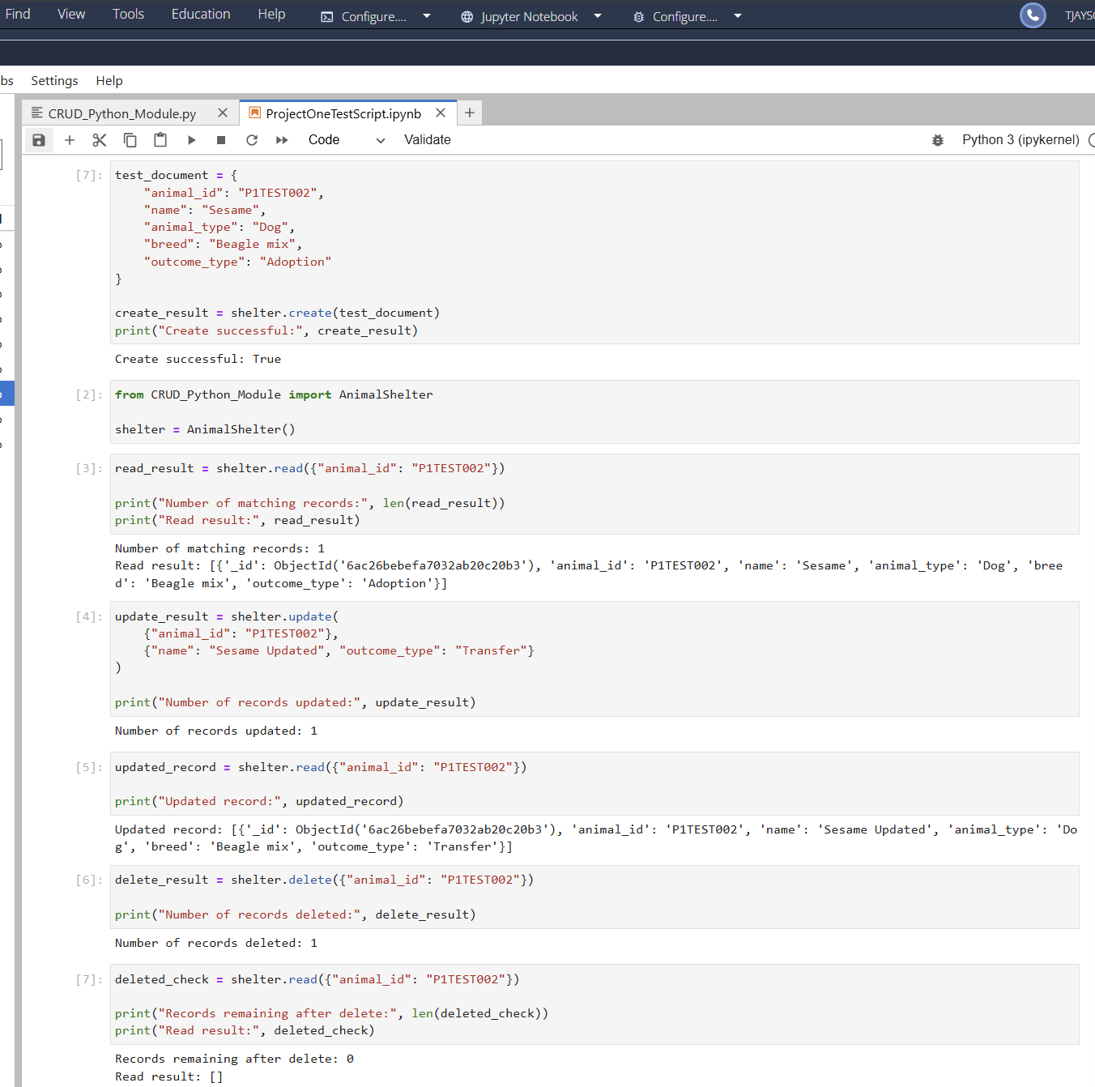

For Project Two, the dashboard was tested by running ProjectTwoDashboard.ipynb and verifying that each interactive component responded correctly. The Water Rescue, Mountain/Wilderness Rescue, Disaster/Individual Tracking, and Reset options were each tested to confirm that the data table updated using the correct MongoDB query. The Breed distribution chart and geolocation map were also tested to verify that they updated based on the filtered data and selected animal.

Water Rescue:
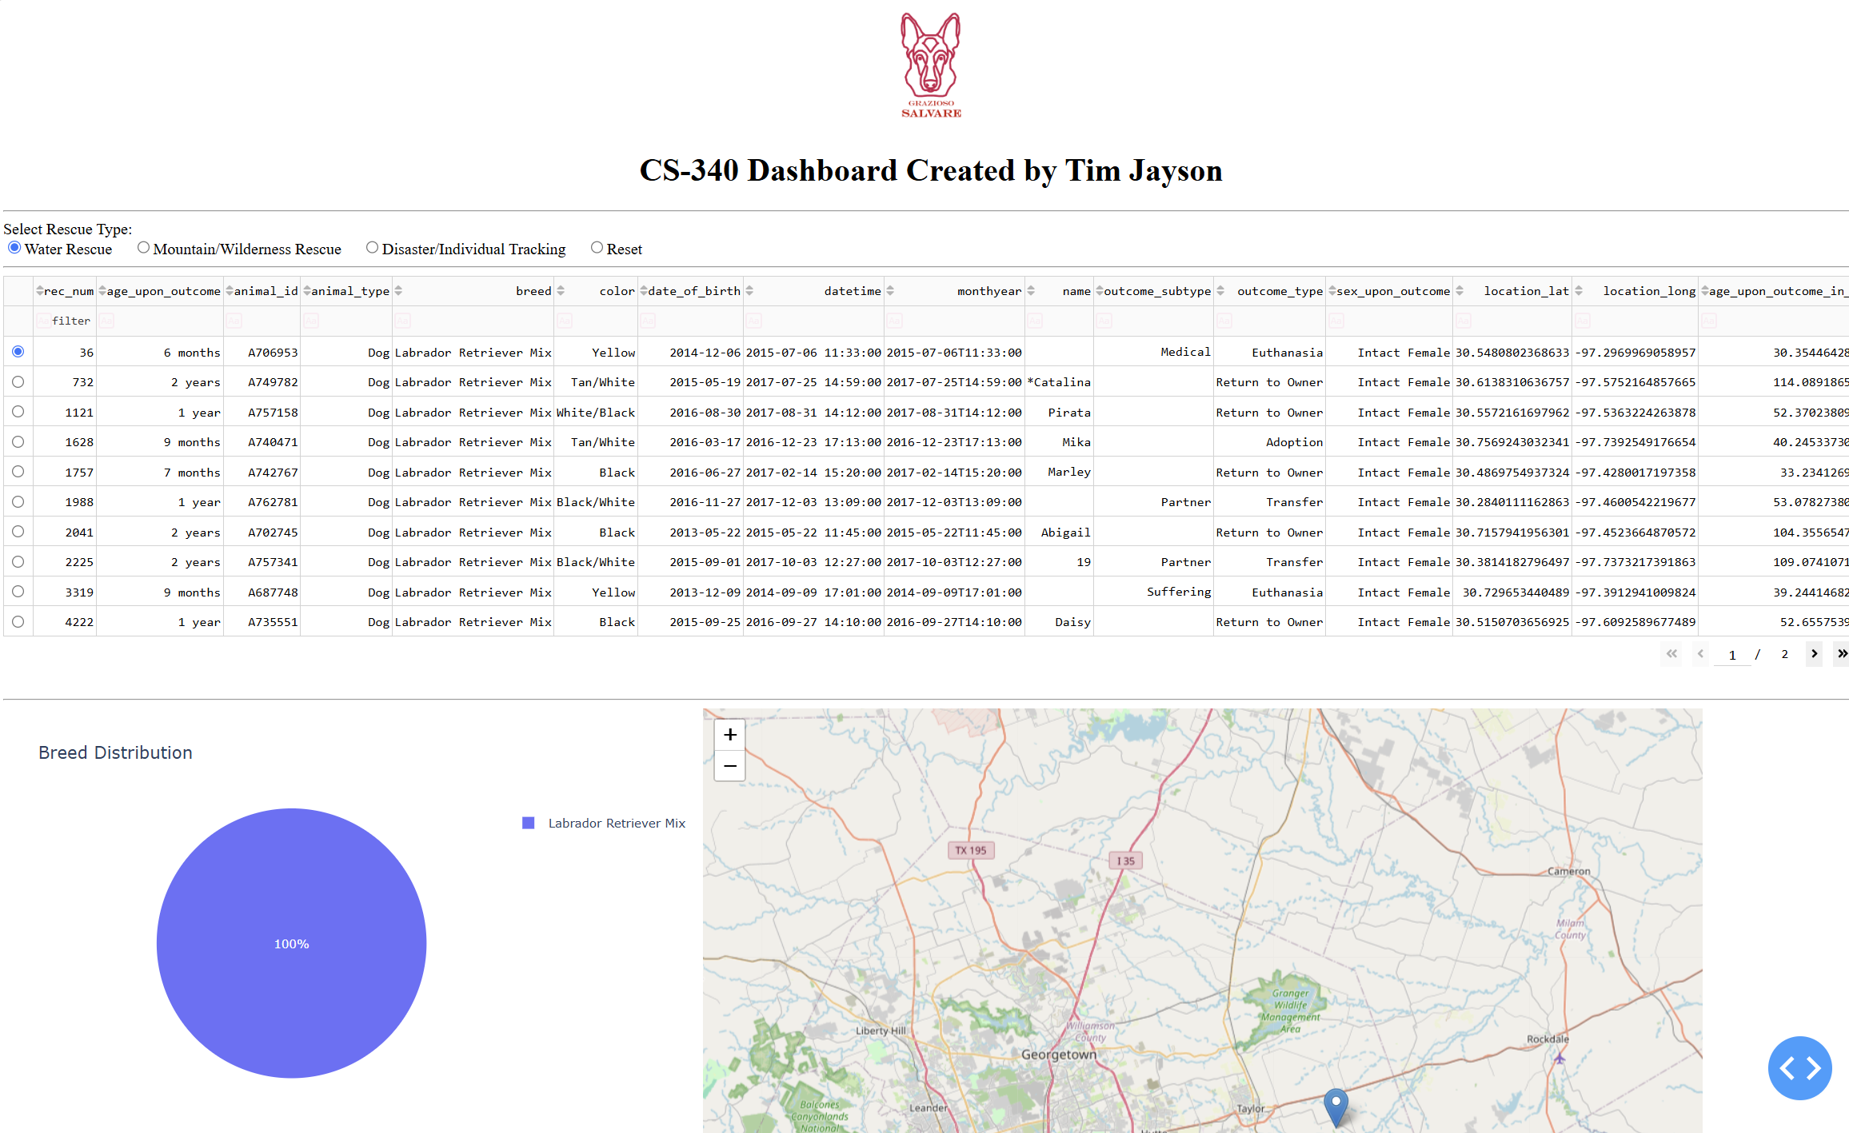
Mountain/Wilderness Rescue:
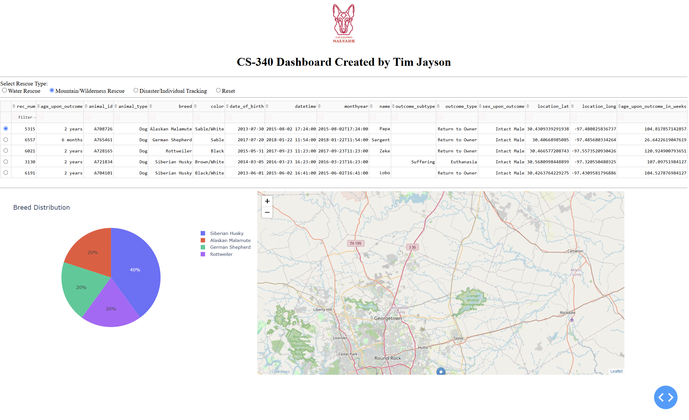
Disaster/Individual Tracking
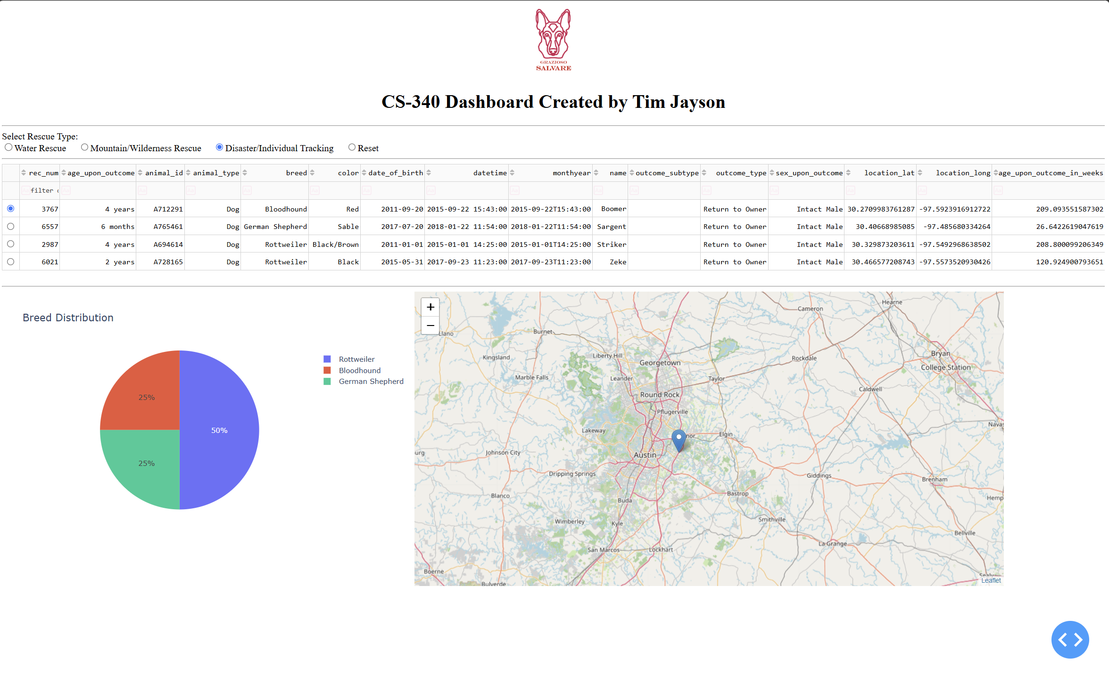
Reset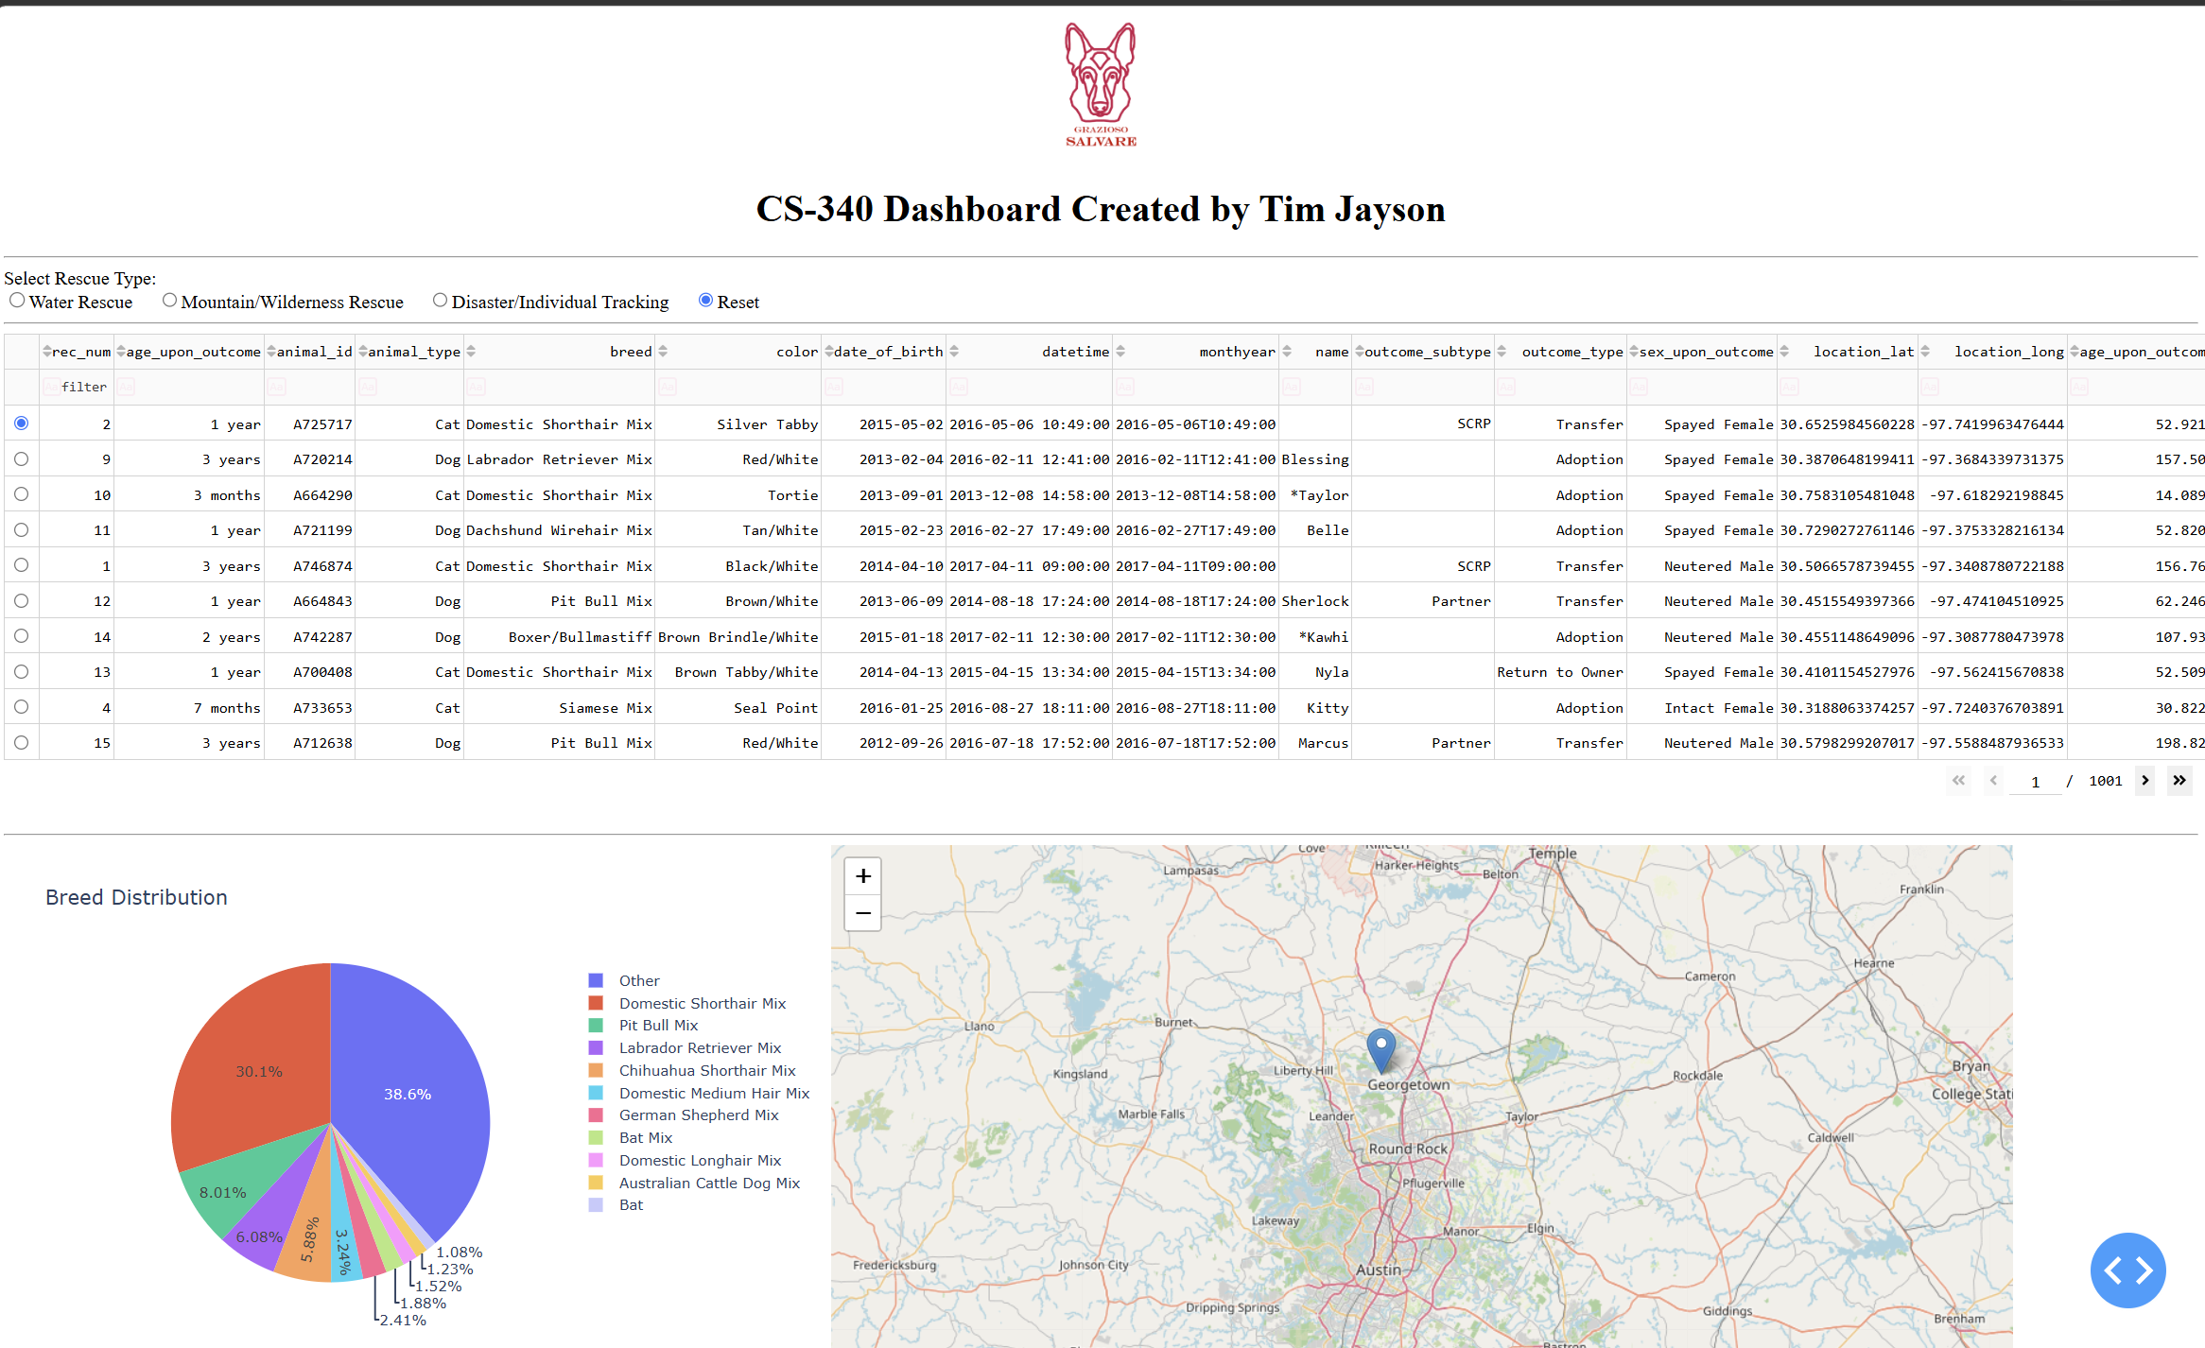
Reproduction Steps
To reproduce this project, first import the Austin Animal Center dataset into MongoDB using the aac database and animals collection. Create the aacuser MongoDB account and assign it the required permissions for the aac database.
Next, import the AnimalShelter class from the CRUD module and create a database connection using the MongoDB username and password.
Run the ProjectTwoDashboard.ipynb notebook in JupyterLab. This retrieves the animal records from MongoDB and converts the results into a Pandas Dataframe. The dashboard then displays the data in an interactive Dash table.
The dashboard include button filters for Water Rescue, Mountain/Wilderness Rescue, Disaster/Individual Rescue, and Reset. Selecting one of these options runs the related MongoDB query and updates the data table, breed distribution pie chart, and the interactive geolocation map.
The geolocation map displays the location of the selected animal from the table, while the breed distribution chart summarizes the breeds currently shown in the filtered data. The Reset option returns the dashboard to the full unfiltered dataset.
Finally, each rescue filter and see that the table, chart, and map all update correctly. The dashboard also displays the Grazioso Salvare logo.

Challenges and Solutions
One challenge I ran into early on was that changes made to the project two dashboard were not appearing when the application was run. The notebook contained 2 more JupterDash applications and layouts from earlier modules (6 and 4 I believe). The older layout was below the project two code and was overriding it when I tried to run it. The solution was to remove those sections.
Another challenge I ran into was the breed distribution pie chart was difficult to read when looking at an unfiltered list. There were too many individual breeds and this was creating an unusable list. I limited it to 10 records and created an “other” category that included all of the rest. This made the pie chart readable while still providing helpful information.

Screenshots
This is the code that allows for the user to create new records
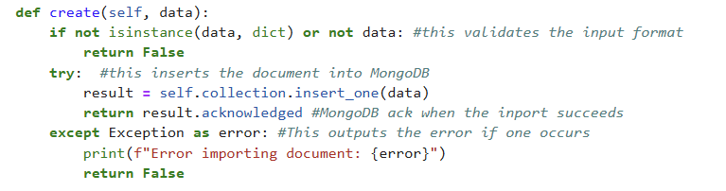

This is the code that allows the user to query the database for records that are already existing.
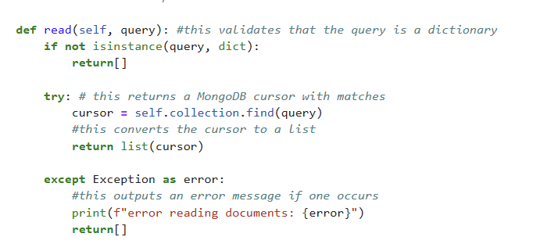

This is the code that allows the user to query the database for records and update the information saved
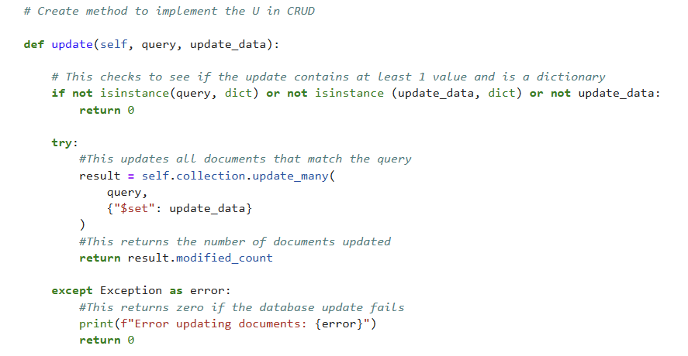

This is the code that allows the user to query the database and delete records
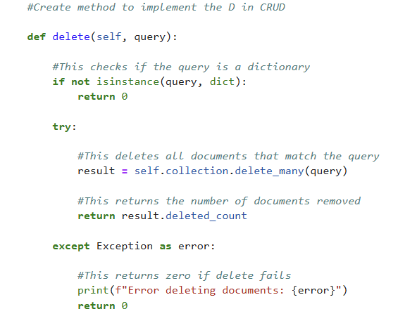

This is the MongoDB import screen shot
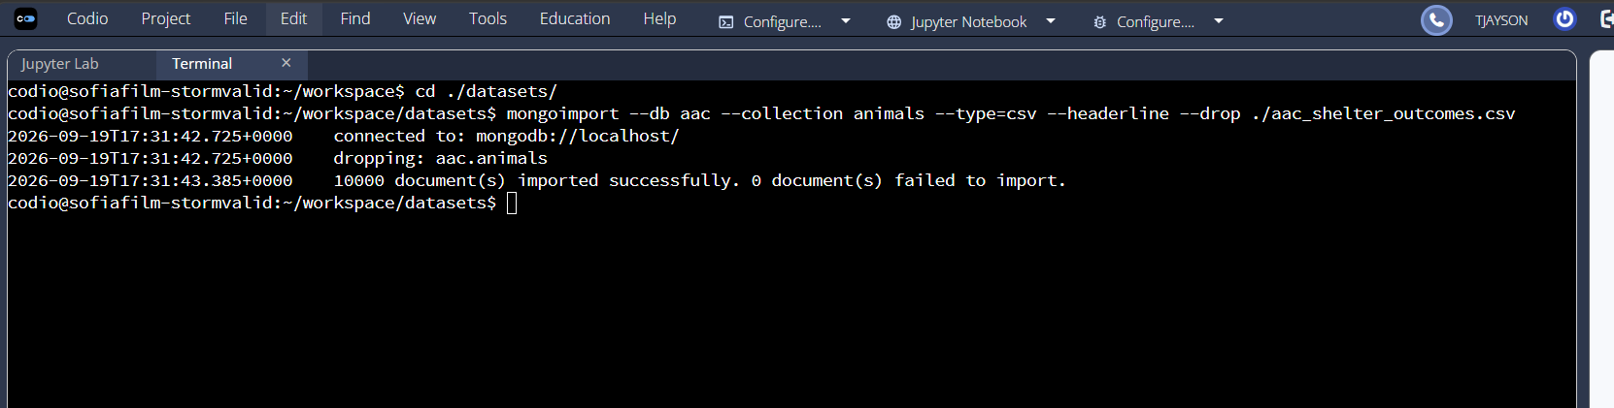

This is the account creation screenshot for the accusr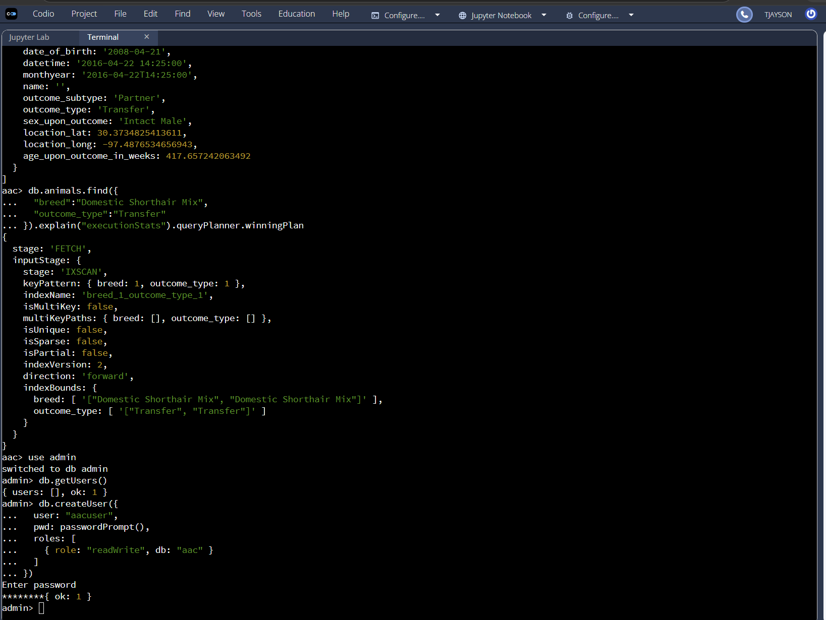
This is the account authentication screenshot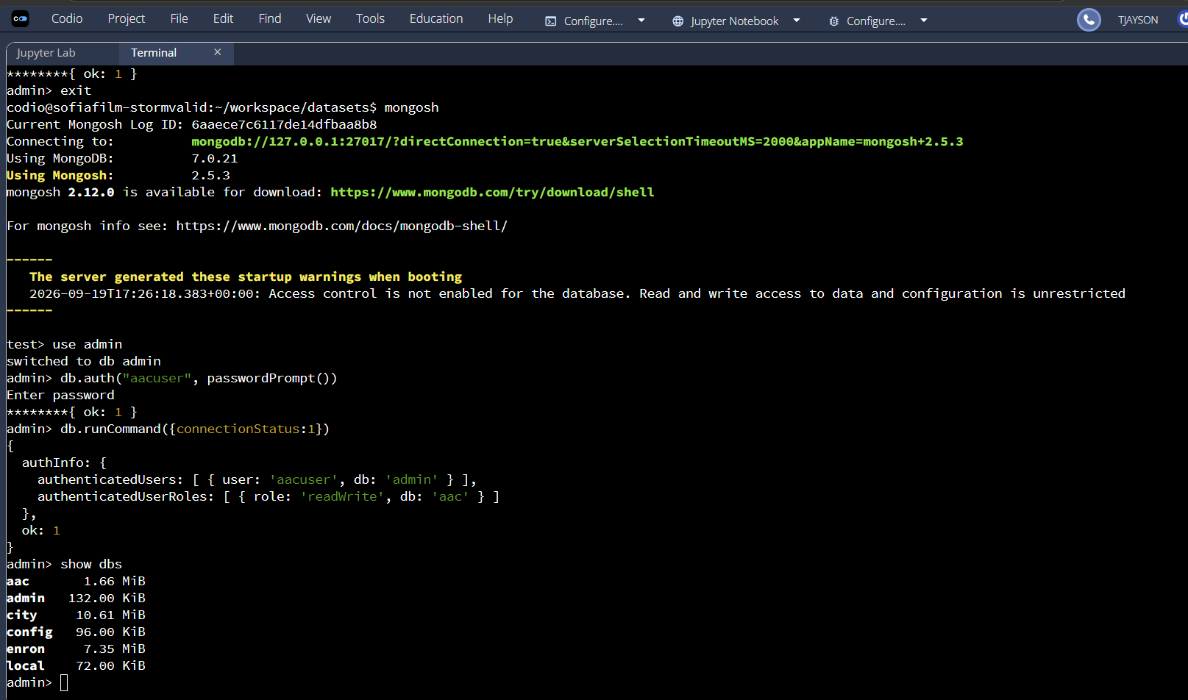

Contact
Your name: Tim Jayson

